IMAT3451 Final Year Project Periodic Progress Report (PPR)

Programme/Course Title: Computer Games Programming

Name: Connor Rowland Assessment Period: Week 1

Project Title: Dobble Report Number: 1

Objectives for Period: (refer to previous report)
N/A

Summary of Progress for Period: (identify evidence of progress)

Problem Areas and Suggested Solutions:

Objectives, Deliverables & Plan for Next Period:

Research:
- Combinatorics
- Algorithms for positioning images on a screen in a certain way.
- Networking (SFML, Winsock2, Linux alts, android networking apis, and what’s available on real-time networking - banking).
- Dobble

Date of Next Review: 24/10/2018

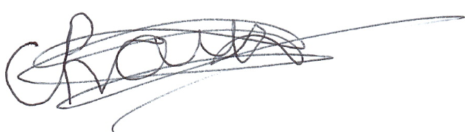
Student’s Signature: Date: 10/10/2018

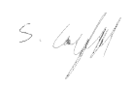
Supervisor’s Signature: Date: 10/10/2018

Comments (if any):

